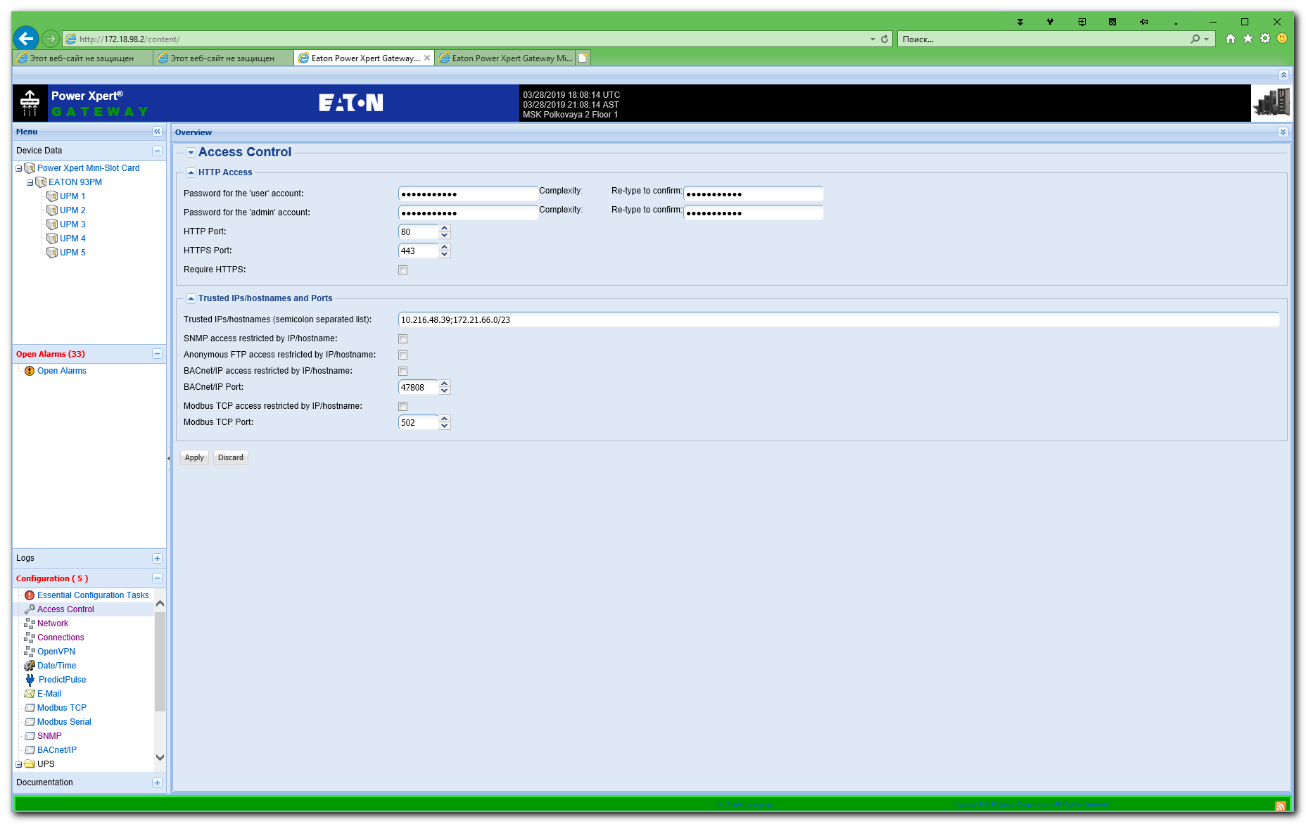

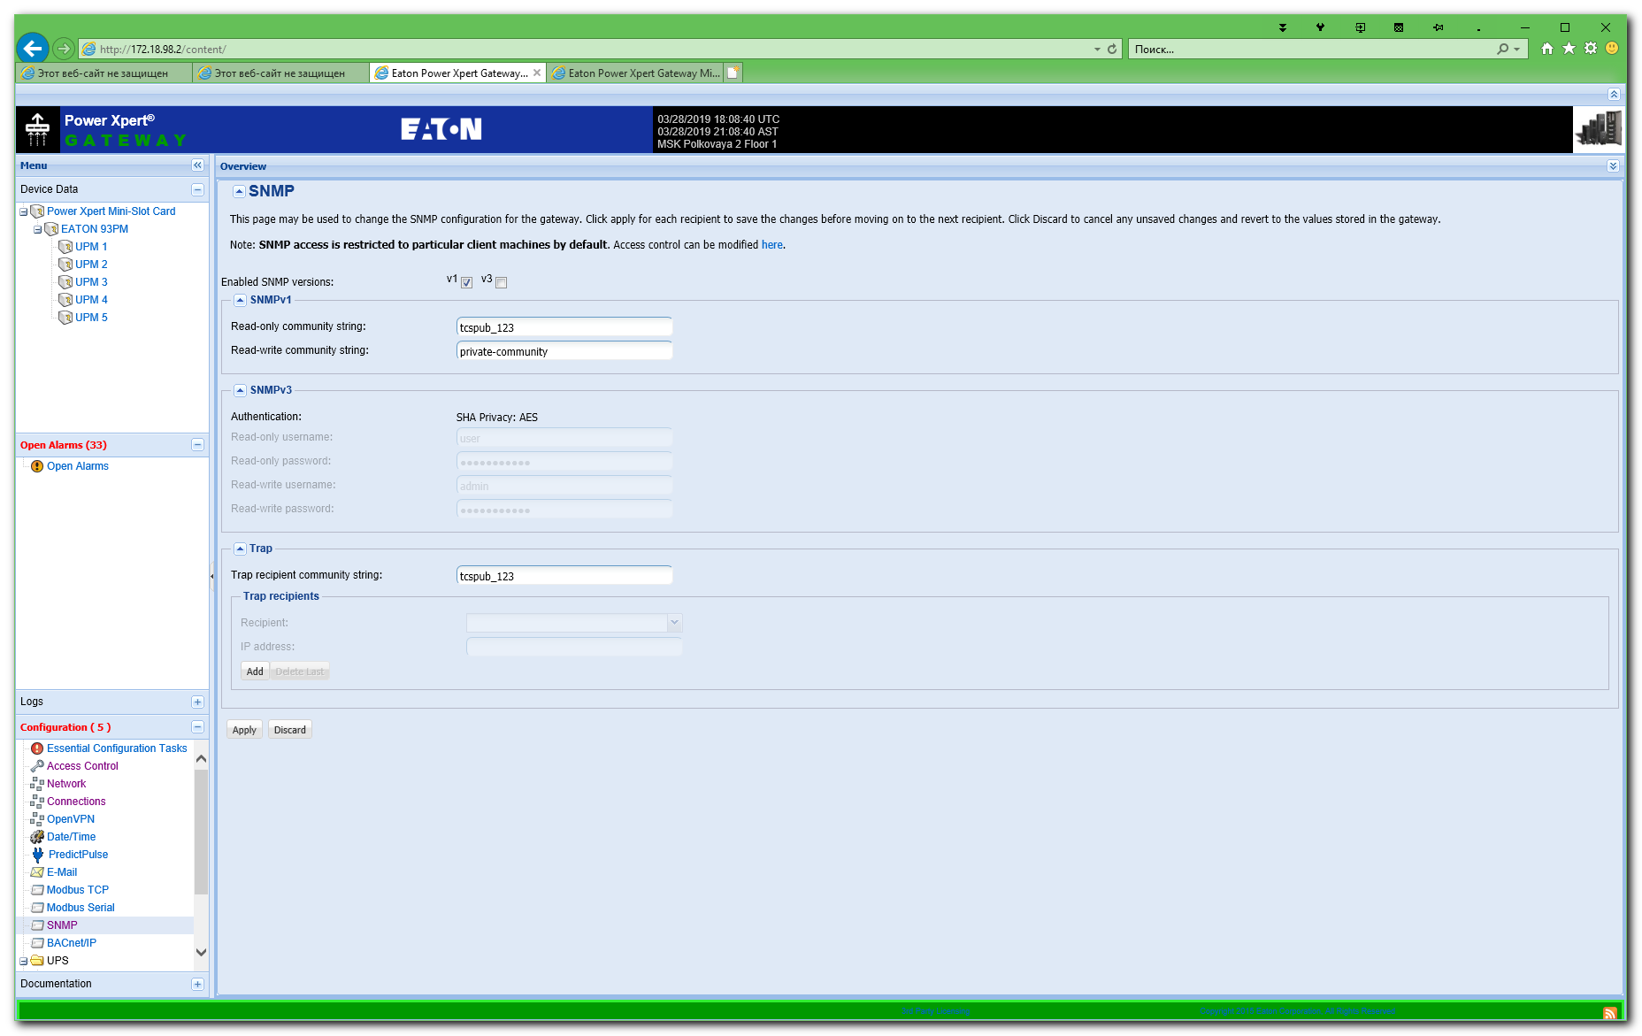

#
# In nagios it was follow two UPS’es.
[root@vm-vol-nag4-tst objects]# ls -1 ups/PL-01-UPS1-Eaton.cfg ups/PL-04-UPS1-Eaton.cfg
ups/PL-01-UPS1-Eaton.cfg
ups/PL-04-UPS1-Eaton.cfg
[root@vm-vol-nag4-tst objects]#

[root@vm-vol-nag4-tst servers]# /usr/local/nagios/libexec/check_snmp -H 172.18.98.2 -o .1.3.6.1.4.1.534.1.3.4.1.2.1 -C tcspub_123 -c200:
SNMP OK - 231 | iso.3.6.1.4.1.534.1.3.4.1.2.1=231
[root@vm-vol-nag4-tst servers]#

#
# Before snmp options on UPS was properly configured - I had absence fo connection.
[root@vm-vol-nag4-tst servers]# /usr/local/nagios/libexec/check_snmp -H 172.18.98.4 -o .1.3.6.1.4.1.534.1.3.4.1.2.1 -C tcspub_123 -c200:
External command error: Timeout: No Response from 172.18.98.4:161.
[root@vm-vol-nag4-tst servers]#

[root@vm-vol-nag4-tst servers]# snmpwalk -v 1 -c tcspub_123 172.18.98.2 . | head
SNMPv2-MIB::sysDescr.0 = STRING: Linux PowerXpert-00-20-85-F1-2E-14 3.2.2 #1 PREEMPT Wed Oct 14 09:39:43 CEST 2015 ppc
SNMPv2-MIB::sysObjectID.0 = OID: SNMPv2-SMI::enterprises.534.2.12
DISMAN-EVENT-MIB::sysUpTimeInstance = Timeticks: (139197265) 16 days, 2:39:32.65
SNMPv2-MIB::sysContact.0 = STRING: Vladislav Lesoviy
SNMPv2-MIB::sysName.0 = STRING: PowerXpert-00-20-85-F1-2E-14
SNMPv2-MIB::sysLocation.0 = STRING: MSK Polkovaya 2 Floor 1
SNMPv2-MIB::sysORLastChange.0 = Timeticks: (11) 0:00:00.11
SNMPv2-MIB::sysORID.1 = OID: UDP-MIB::udpMIB
SNMPv2-MIB::sysORID.2 = OID: SNMPv2-MIB::snmpMIB
SNMPv2-MIB::sysORID.3 = OID: SNMP-VIEW-BASED-ACM-MIB::vacmBasicGroup
[root@vm-vol-nag4-tst servers]#

[root@vm-vol-nag4-tst servers]# snmpwalk -v 1 -c tcspub_123 172.18.98.4 . | head
SNMPv2-MIB::sysDescr.0 = STRING: Linux PowerXpert-00-20-85-F1-4E-54 3.2.2 #1 PREEMPT Wed Oct 14 09:39:43 CEST 2015 ppc
SNMPv2-MIB::sysObjectID.0 = OID: SNMPv2-SMI::enterprises.534.2.12
DISMAN-EVENT-MIB::sysUpTimeInstance = Timeticks: (743) 0:00:07.43
SNMPv2-MIB::sysContact.0 = STRING: Moroz
SNMPv2-MIB::sysName.0 = STRING: PowerXpert-00-20-85-F1-4E-54
SNMPv2-MIB::sysLocation.0 = STRING: MSK Polkovaya 2 Floor 4
SNMPv2-MIB::sysORLastChange.0 = Timeticks: (58) 0:00:00.58
SNMPv2-MIB::sysORID.1 = OID: UDP-MIB::udpMIB
SNMPv2-MIB::sysORID.2 = OID: SNMPv2-MIB::snmpMIB
SNMPv2-MIB::sysORID.3 = OID: SNMP-VIEW-BASED-ACM-MIB::vacmBasicGroup
[root@vm-vol-nag4-tst servers]#

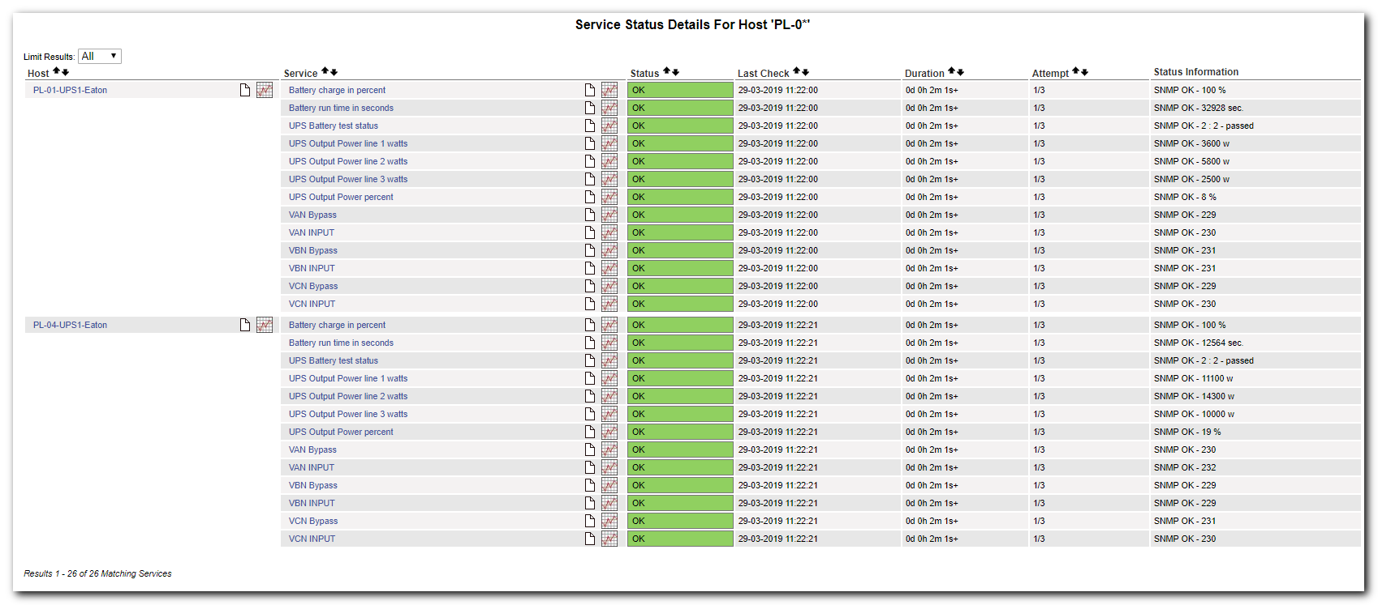

[root@vm-vol-nag4-tst objects]# cat ups/PL-01-UPS1-Eaton.cfg
define host{
use ups-server
host_name PL-01-UPS1-Eaton
address 172.18.98.2
}

define service{
use generic-service
host_name PL-01-UPS1-Eaton
service_description VAN INPUT
check_command check_snmp!-o .1.3.6.1.4.1.534.1.3.4.1.2.1 -C tcspub_123 -c200:
}
define service{
use generic-service
host_name PL-01-UPS1-Eaton
service_description VBN INPUT
check_command check_snmp!-o .1.3.6.1.4.1.534.1.3.4.1.2.2 -C tcspub_123 -c200:
}
define service{
use generic-service
host_name PL-01-UPS1-Eaton
service_description VCN INPUT
check_command check_snmp!-o .1.3.6.1.4.1.534.1.3.4.1.2.3 -C tcspub_123 -c200:
}
define service{ [31/261]
use generic-service
host_name PL-01-UPS1-Eaton
service_description VAN Bypass
check_command check_snmp!-o .1.3.6.1.4.1.534.1.5.3.1.2.3 -C tcspub_123 -c200:
}

define service{
use generic-service
host_name PL-01-UPS1-Eaton
service_description VBN Bypass
check_command check_snmp!-o .1.3.6.1.4.1.534.1.5.3.1.2.2 -C tcspub_123 -c200:
}
define service{
use generic-service
host_name PL-01-UPS1-Eaton
service_description VCN Bypass
check_command check_snmp!-o .1.3.6.1.4.1.534.1.5.3.1.2.1 -C tcspub_123 -c200:
}
define service{
use generic-service
host_name PL-01-UPS1-Eaton
service_description Battery run time in seconds
check_command check_snmp!-o .1.3.6.1.4.1.534.1.2.1.0 -C tcspub_123 -c4000: -usec.
}
define service{
use generic-service
host_name PL-01-UPS1-Eaton
service_description Battery charge in percent
check_command check_snmp!-o .1.3.6.1.4.1.534.1.2.4.0 -C tcspub_123 -w50: -c10: -u%
}
define service{
use generic-service
host_name PL-01-UPS1-Eaton
service_description UPS Battery test status
check_command check_snmp!-o .1.3.6.1.4.1.534.1.8.2.0 -C tcspub_123 -P 1 -c2:2 -u": 2 - passed| 3 - failed| 4 - inProgress| 5 - notSupported| 6 - inhibited| 7 - scheduled"
}
define service{
use generic-service
host_name PL-01-UPS1-Eaton
service_description UPS Output Power percent
check_command check_snmp!-o enterprises.534.1.4.1.0 -C tcspub_123 -P 1 -u"%"
}
define service{
use generic-service
host_name PL-01-UPS1-Eaton
service_description UPS Output Power line 1 watts
check_command check_snmp!-o enterprises.534.1.4.4.1.4.1 -C tcspub_123 -P 1 -u"w"
}
define service{
use generic-service
host_name PL-01-UPS1-Eaton
service_description UPS Output Power line 2 watts
check_command check_snmp!-o enterprises.534.1.4.4.1.4.2 -C tcspub_123 -P 1 -u"w"
}
define service{
use generic-service
host_name PL-01-UPS1-Eaton
service_description UPS Output Power line 3 watts
check_command check_snmp!-o enterprises.534.1.4.4.1.4.3 -C tcspub_123 -P 1 -u"w"
}
[root@vm-vol-nag4-tst objects]#

